EXPERIMENT – 11
Perform a 180-Degree Rotation Clockwise Along the Y-Axis for the Given Image
Aim
To rotate an image by 180 degrees clockwise using Python and OpenCV.
Procedure
- Import the OpenCV library.
- Read the input image using cv2.imread().
- Check whether the image is loaded successfully.
- Rotate the image by 180 degrees using cv2.rotate().
- Display the original and rotated images.
- Wait for a key press and close all image windows.
Program
import cv2

image = cv2.imread("image.jpg")

if image is None:
print("Image not found!")
else:
rotated = cv2.rotate(image, cv2.ROTATE_180)

cv2.imshow("Original Image", image)
cv2.imshow("180 Degree Clockwise Rotation", rotated)

cv2.waitKey(0)
cv2.destroyAllWindows()
Sample Input
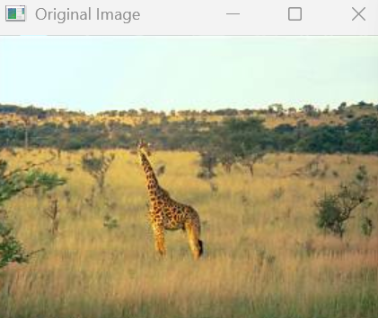
Sample Output
Image rotated 180 degrees.
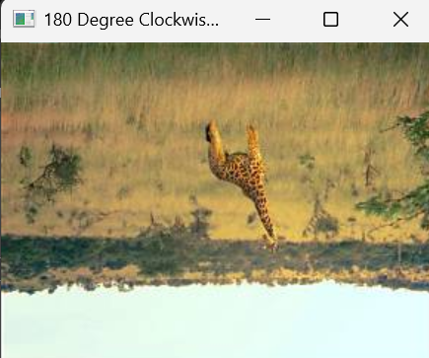
Result
Thus, the image was successfully rotated by 180 degrees clockwise using Python and OpenCV.

